Item | Manufacturer | Model | Colour | Size | Date of Manufacture | Reason for sale | Price (inc VAT) | Image | Comments
Helmet | Future Safety | Manta Pro | White | One |  | Ex Display | RRP £83.20  £56.70 | 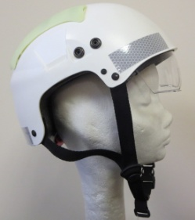 | Multi-role helmet with Photo-luminescent vent covers, Solas reflective strips, integral drop down visor and maritime studs
Hemet | Future Safety | Manta Pro | Yellow | One |  | Ex Display | RRP £83.20  £56.70 | 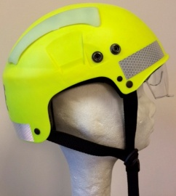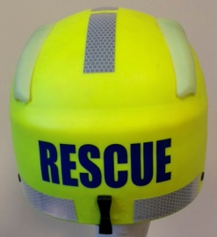 |  | As above. Cosmetic scratches on integral visor
Helmet | Future Safety | Manta Basic | Yellow | One |  | Ex Display | RRP £75.00  £50.40 | 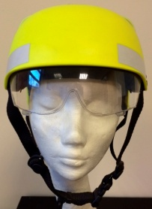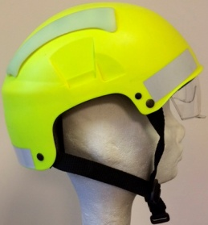 |  | Multi-role helmet with Photo-luminescent vent covers, basic reflective strips and integral drop down visor
Helmet | Petzl | Elia | Purple | One | 14 Jun 2013 | Ex Display | RRP £53.76  £35.55 | 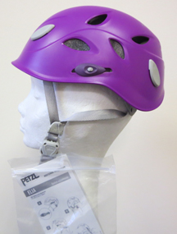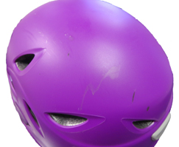 |  | Scratches on top
Helmet | Protec | Ace Water | Gloss yellow | Large |  | Clearance | RRP £59.99  £29.70 | 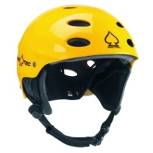
Helmet | DMM | Ascent (Kids) | Orange | 48-57cm |  | Clearance | RRP £47.00  £28.79 | 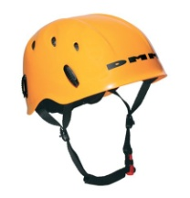
Ear Defenders | MSA | EXC Cap Mounted Earmuff | White | N/A | N/A | Clearance | £12.00 | 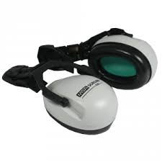
Descender  Descender  Descender  Descender  Descender | Petzl  Petzl  Petzl  Petzl  Petzl | Stop  Stop  Stop  Stop  Stop | Blue  Blue  Blue  Blue  Blue | N/A  N/A  N/A  N/A  N/A | 19 June 2012  19 June 2012  19 June 2012  19 June 2012  19 June 2012 | Pre-engraved  DDPU154  Pre-engraved  DDPU156  Pre-engraved  DDPU157  Pre-engraved  TEKSTO45  Pre-engraved  TEKSTO52 | RRP £90.00  £57.00 | 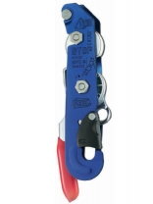 |  | No box  No Box  No Box
Gloves  Gloves | Nookie  Nookie | Xtreme  Xtreme | Black / Grey  Black / Grey | XXL  XL | N/A  N/A | Stock Clearance  Stock Clearance | RRP £29.99  £18.90 | 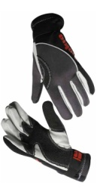
Chalkbag  Chalkbag | Petzl  Petzl | SAKA  SAKA | Red  Red | N/A  N/A | N/A  N/A | Stock Clearance  Stock Clearance | RRP £17.50  £11.50 | 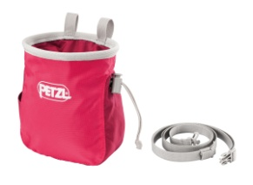
Chalkbag  Chalkbag | Petzl  Petzl | BANDI  BANDI | Grey/Red  Jade Green | N/A  N/A | N/A  N/A | End of Line  End of Line | RRP £14.00  £9.20 | 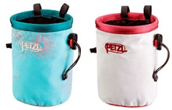
Knife  Kinfe | Gerber  Gerber | River Runner  River Runner | Black  Black | N/A  N/A | N/A  N/A | Stock Clearance  Stock Clearance | £39.20 | 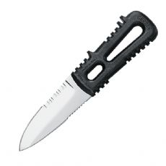 |  | 3.75 in fixed blade  With sheath
Knife | Edelrid | Rope Tooth Knife | Black/green | N/A | N/A | Stock Clearance | £15.00 | 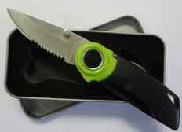 |  | Comes with presentation tin
Nylon Sling  Nylon Sling  Nylon Sling  Nylon Sling  Nylon Sling  Nylon Sling | Lyon  Lyon  Lyon  Lyon  Lyon  Lyon | LSL18.480  LSL18.480  LSL18.480  LSL18.480  LSL18.480  LSL18.480 | Black  Black  Black  Black  Black  Black | 18mm x 480cm  18mm x 480cm  18mm x 480cm  18mm x 480cm  18mm x 480cm  18mm x 480cm | 05 Mar 2013  08 Jun 2012  22 Sep 2010  22 Sep 2010  22 Sep 2010  22 Sep 2010 | Stock Clearance  Stock Clearance  Stock Clearance  Stock Clearance  Stock Clearance  Stock Clearance | RRP £15.76  £10.33 | 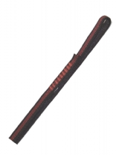
Nylon Sling  Nylon Sling  Nylon Sling  Nylon Sling  Nylon Sling  Nylon Sling | Lyon  Lyon  Lyon  Lyon  Lyon  Lyon | LSL18.240  LSL18.240  LSL18.240  LSL18.240  LSL18.240  LSL18.240 | Black  Black  Black  Black  Black  Black | 18mm x 240cm  18mm x 240cm  18mm x 240cm  18mm x 240cm  18mm x 240cm  18mm x 240cm | 13 Oct 2014  18 Jul 2013  30 Aug 2011  11 Jul 2011  04 Jan 2011  14 Apr 2010 | Stock Clearance  Stock Clearance  Stock Clearance  Stock Clearance  Stock Clearance  Stock Clearance | RRP £9.00  £5.89
PFD  PFD | Palm  Palm | Rescue 825  Rescue 825 | Red  Red | M/L  M/L |  | Ex-Display  End of Line | RRP £164.95  £130.00 | 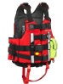
PFD | Palm | Rescue 800 | Red | S/M |  | End of Line | RRP £139.96  £111.00 | 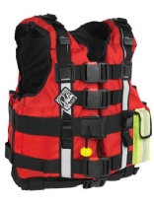
Tool Lanyard Set | G-Force | For wrist and waist | Black | One |  | Last One | RRP £12.95  £9.20 | 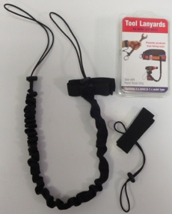 |  | We are also throwing in a second wrist lanyard for free!
Bag | Stopdrop  Tooling | Round bag plus water bottle holder | Black / yellow | Approx Dimensions:  Bag height 42cm  Diameter 19cm |  | Clearance | £25.00 | 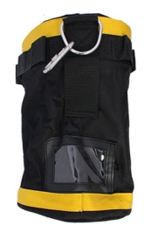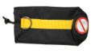 |  | Water bottle holder suitable for 0.5l bottle
Bag | Red Road | Leg Bag | Black | Approx. dim 26cm tall x 14cm diameter | N/A | Clearance | £20.00 | 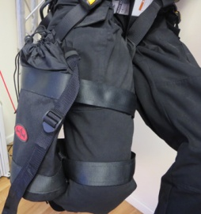
Harness – Sit  Harness – Sit  Harness - Sit | DMM  DMM  DMM | Brenin  Brenin  Brenin | Black  Black  Black | Regular  Regular  Regular |  | Clearance  Clearance  Clearance | RRP £45.00  £34.50 | 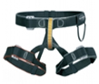
Harness  Harness  Harness | Petzl  Petzl  Petzl | 8003  8003  8003 | Black  Black  Black | 2 (M-XL)  2 (M-XL)  1 (XS-L) | 08 Dec 2011  01 Aug 2013  10 Feb 2014 | Clearance  Clearance  Clearance | RRP £87.99  £57.75 | 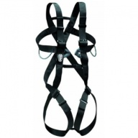
Harness | Petzl | Avao Sit | Black | 2 | 23 Jan 2013 | Clearance | RRP £170.62  £112.00 | 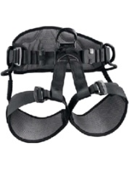
Rope Protector | Troll |  | White Canvas | 90cm |  | Clearance | £11.00 | 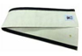
Rope Protector | RopePro |  | Yellow / Blue | 50cm |  | Clearance | £13.22 | 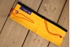
Rope Protector  Rope Protector | Spiroll  Spiroll |  | Black  Orange | 60cm  60cm |  | Clearance  Clearance | £10.00 | 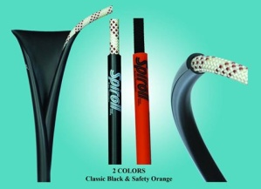
Toddler Backpack | Littlelife | Turtle | Turtle (green) | 6 months-4 years | N/A | Clearance | RRP £19.99  £13.90 | 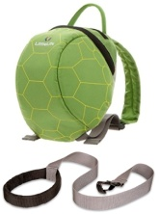
Lanyard  Lanyard | Petzl  Petzl | Joko Y  Joko Y |  | 85cm  85cm | 21 Oct 2013  13 Sep 2012 | End of Line  End of Line | RRP £30.00  £19.70 | 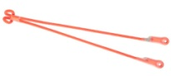
Lanyard | Petzl | Joko I |  | 70cm | 20 Aug 2012 | End of Line | RRP £18.00  £12.20
Wire Lanyard | Lyon |  |  | 140cm | 21 Mar 2011 | Clearance | RRP £27.00  £17.80 | 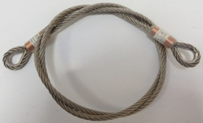
Throwline | Palm | Bullet floating PP line | N/A | 11mm x 15m |  | Clearance | RRP £34.95  £28.70 | 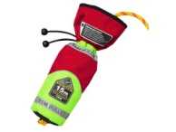
Back-up | DMM | Buddy 200 | Red | N/A | 16 Jan 2012 | Clearance | RRP £69.99  £47.80 | 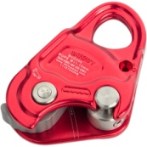
Sunglasses | Julbo | Race | Black | N/A | N/A | End of Line | RRP £110.00  £72.00 | 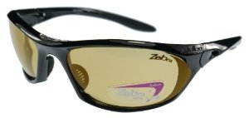 |  | With Zebra photochromic lenses
Hat – Kids | Marmot | Kipster | Green | One |  |  | RRP £20.00  £8.00 | 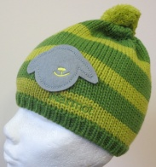 |  | Tag says girls hat, but my son has one and it looks great
Hat - Kids | Marmot | Kipster | Dark Pink | One |  |  | RRP £20.00  £8.00 | 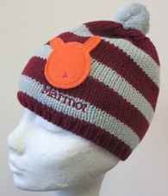
Anchor – caving bolt hanger | Petzl | Vrillee | Stainless Steel | 8mm  15kN |  |  | RRP £3.99 ea  £2.62 each | 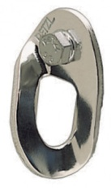 |  | 15 hangers with bolts for sale  With 5 x spare bolts
Karabiner | Palm | Whitewater Wire Gate | Red |  | Feb 2009 | End of Line | RRP £10.95  £7.50 | 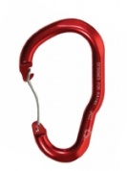
Karabiner | Palm | Auto Lock | Silver |  | Apr 2010 | End of Line | RRP £15.95  £11.00 | 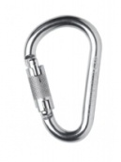
Karabiner | Edelrid | Pure Screw  Screwgate | Silver |  |  | Clearance | £6.00 | 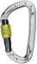
Karabiner  Karabiner  Karabiner  Karabiner | Ridgegear  Ridgegear  Ridgegear  Ridgegear | RGK2  RGK2  RGK2  RGK2 | Steel  Steel  Steel  Steel |  |  | Clearance  Clearance  Clearance  Clearance | RRP £6.88  £5.15 | 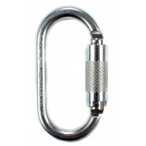 |  | Triple Action, Steel  Triple Action, Steel  Triple Action, Steel  Triple Action, Steel
Compass | Silva | Field 7 |  | N/A | N/A | Clearance | £11.99 | 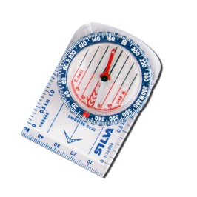
Wire Cutters | Felco | CDO | Black |  |  | Clearance | RRP £64.99  £55.00 | 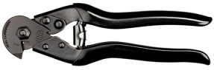 |  | For wire up to 5mm
Waterproof Case | Aquapac | Small Walkie-Talkie case | Blue |  |  | End of Line | RRP £29.00  £19.10 | 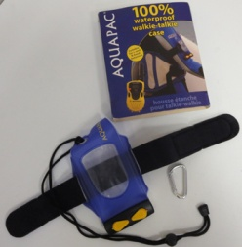 |  | Pack contains, waterproof case, armband, lanyard and snap lock accessory karabiner
Waterproof Case | Aquapac | Micro Whanganui | Clear/Grey | N/A | N/A | End of Line | RRP £19.35  £12.70 | 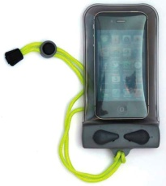 |  | Fits IPhone 4 sized tech  Touch sensitive
Waterproof Case  Waterproof  Case | Aquaquest  Aquaquest | VHF Dry Bag  VHF Dry Bag | Yellow  Yellow | N/A  N/A | N/A  N/A | End of Line  End of Line | RRP £27.00  £17.72 | 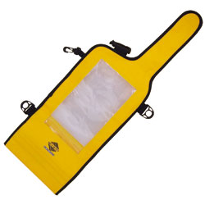
Suspension Trauma Strap | Tractel | S.C. | Black | N/A | N/A | Clearance | £10.00 | 